Ideation Phase
Brainstorm & Idea Prioritization Template

Date | 02/10/2026
Team ID | SWTID-2026-3118
Project Name | IMPORT DATA USING TRANSFORM MAPS (SPREADSHEET)
Maximum Marks | 4 Marks

Brainstorm & Idea Prioritization Template:
Brainstorming provides a free and open environment that encourages everyone within a team to participate in the creative thinking process that leads to problem solving. Prioritizing volume over value, out-of-the-box ideas are welcome and built upon, and all participants are encouraged to collaborate, helping each other develop a rich amount of creative solutions.
Use this template in your own brainstorming sessions so your team can unleash their imagination and start shaping concepts even if you're not sitting in the same room.
Reference: https://www.mural.co/templates/brainstorm-and-idea-prioritization
Step-1: Team Gathering, Collaboration and Select the Problem Statement
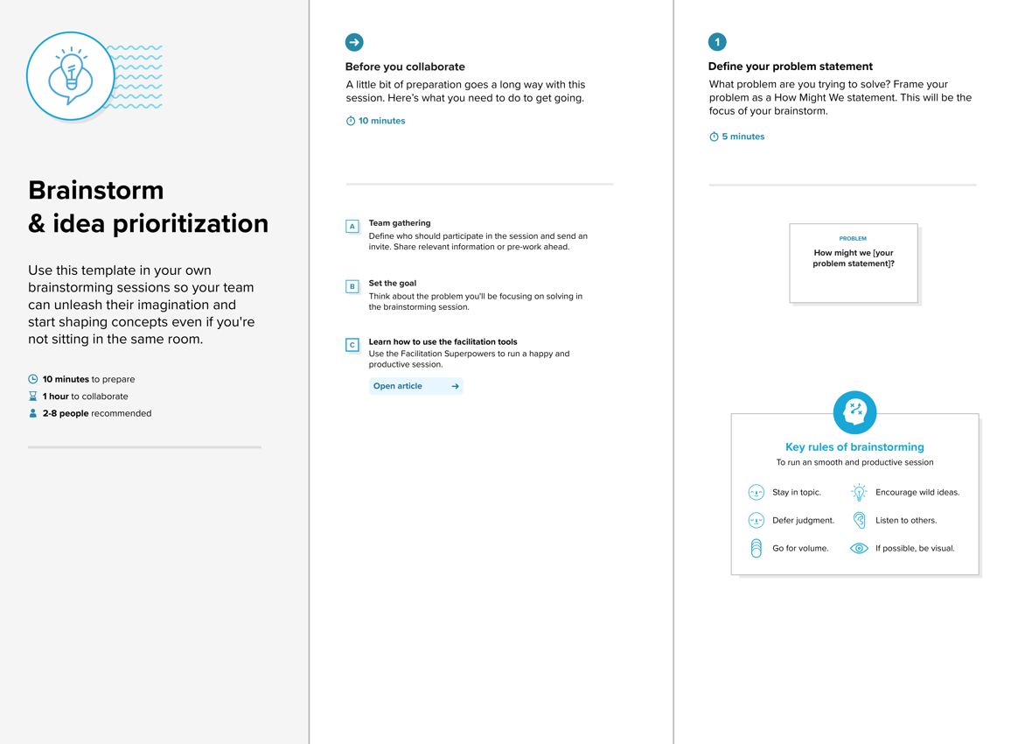

Step-2: Brainstorm, Idea Listing and Grouping
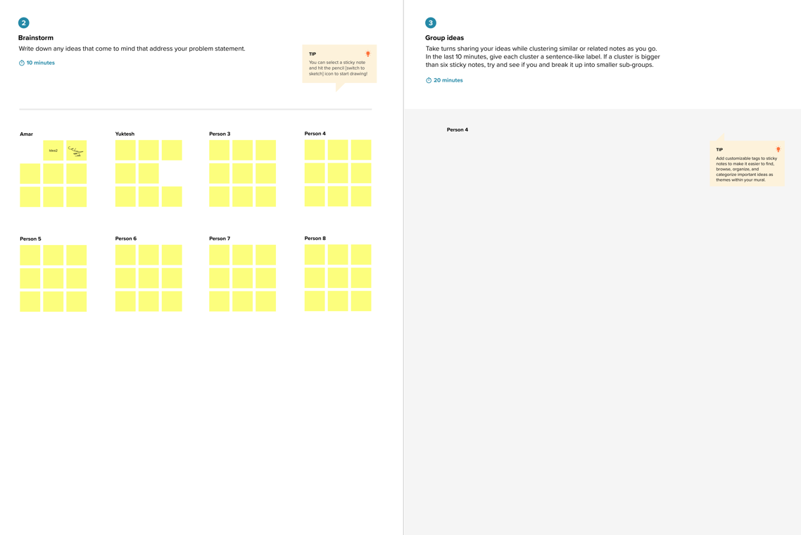

Step-3: Idea Prioritization
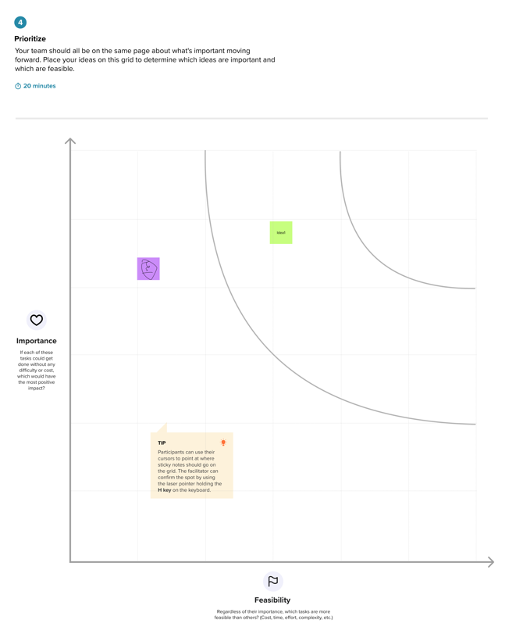

Project Brainstorm and Idea Prioritization
Focus question: How might we import employee spreadsheet data accurately, update existing employees by Employee ID, and make each import outcome easy to verify?
Idea generation
Idea | Theme | Value
Standardize the spreadsheet headers and verify required values before loading. | Data quality | Catches missing or inconsistent source data early.
Stage spreadsheet rows in the Employee Import table before transforming them. | Safe import | Separates incoming data from the Employee Test target records.
Auto-map matching fields, then confirm any remaining fields with Mapping Assist. | Field mapping | Reduces setup effort while keeping target-field choices explicit.
Coalesce on Employee ID so repeat imports update the matching employee. | Duplicate control | Updates changed details and avoids duplicate employee records.
Review Transform History for inserted, updated, ignored, and failed rows. | Traceability | Shows what happened in each import run and supports follow-up.
Create Department and Location count reports plus an employee list. | Reporting | Makes the imported population easier to check and summarize.
Put the reports on an Employee Analytics dashboard. | Monitoring | Gives HR and administrators one place to view key employee data.
Prioritization
Ranked by expected impact and feasibility for the spreadsheet-import project.
Concept | Impact | Feasibility | Rank
Import Set + Transform Map + Employee ID Coalesce | High | High | 1
Check required fields and confirm source-to-target mappings before transform | High | Medium | 2
Verify inserted, updated, ignored, and failed rows in Transform History | High | High | 2
Add Department and Location reports to the employee dashboard | Medium | High | 3
Selected concept: Use an Import Set and Transform Map with explicit field mappings and Employee ID coalesce, then verify the results in Transform History and the employee table.

